The key to empirical studies is knowing the value of evidence.

Knowing the value of evidence:
quality of data
+
quality of inference

establish:
relevance
credibility
inferential force

“We need experience in a
real environment to figure out
what the critical variables are…”

“…practical experience leads to a
better development of relevant theory.”
Bill Curtis, 5 June 2000

THEORY
You are here.
Where does theory come from?
hypothetico-deductive method

Appeal to method of science:
observe – articulate – categorise – model – theorise – challenge

Finding better questions
Science is about learning, not proving

so what?
importance of question
significance of findings
implications for theory
limitations to generalisation

Richness/ | Rigour/
Realism | Control
reflecting reality | replicable
(natural phenomena) | repeatable
‘practical’ | reliable
valid
but
“Real data is real dirty.” | sand through the fingers
reliability? | relevance?

Mason, 1989

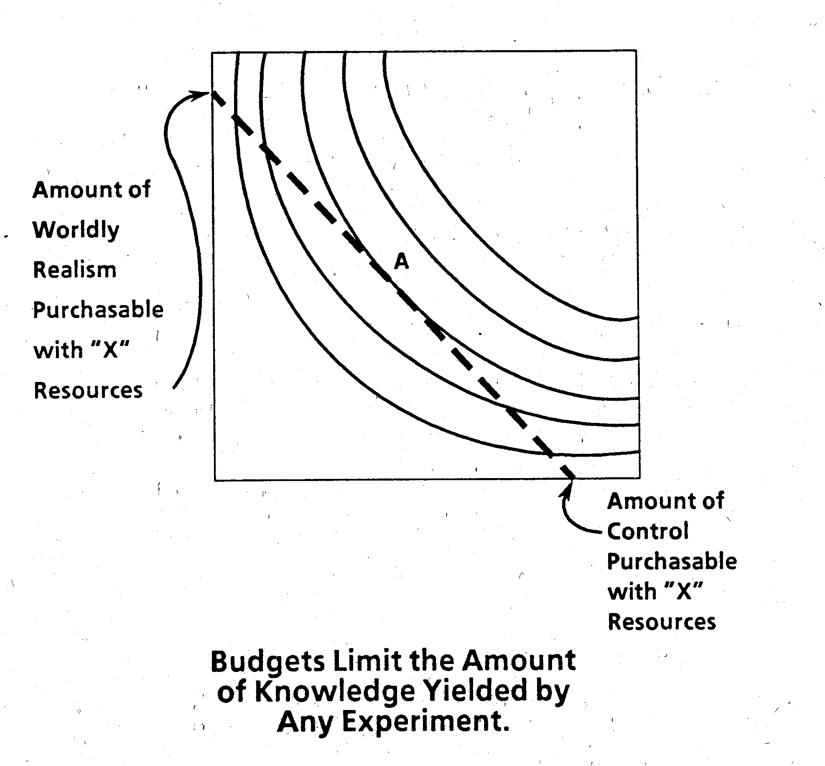

Mason, 1989

costs:
planning
execution
analysis

Think about analysis when you plan data collection:
What are you going to do with all this data?
How will you make sense of it?

Trade off between value and cost
to achieve fitness for purpose.

